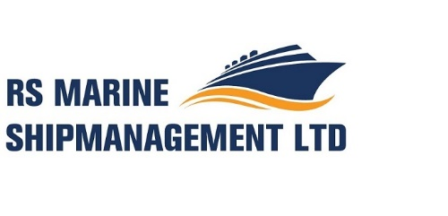
On-board Complaint Form & Procedure

Name of Ship : __________________

IMO Number : __________________

Contact Information
A. Person/persons (rank or position) on board the ship authorized to provide seafarers with
confidential and impartial advice on a complaint and otherwise assist in following the onboard complaint procedures:

a:
b:

B. Contact information of the company ashore designated by the ship owner/charterer for
handling on-board complaints:

Name : RS Marine Shipmanagement Limited
Telephone : +357 24 251 678
Email address : operations@rsmarine.eu
Website : www.rsmarine.eu

C. Contact information of the competent authority in the applicable flag State of the vessel:

Name : Department of Maritime Labour Affairs Panama Maritime Authority
Telephone : (507) 501-5059 / 5067 | Fax: (507) 501-5210
E-mail address : labormar@amp.gob.pa

Name : Department of Merchant Shipping Cyprus
Telephone : +357-25 823715 / Fax : +357-25 305030
E-mail address : mlc@dms.mcw.gov.cy

D. Contact information of the competent authority in the seafarers’ country of residence can be
found on the ILO-website (click on the relevant country):
http://www.ilo.org/dyn/normlex/en/f?p=NORMLEXPUB:80001:0::NO

Briefly describe your complaint. If more space is needed please attach additional pages.
_________________________________________________________________________
_________________________________________________________________________
_________________________________________________________________________
_________________________________________________________________________
_________________________________________________________________________

Procedure

1. Seafarers with a complaint shall submit the matter in writing within five days of the
occurrence, or according to the circumstances, following the under mentioned hierarchy:

a. Superior Officer
b. Head of Department
c. Master

Each has a further five (5) days to solve the complaint.

2. Complaints shall be sought to be resolved at the lowest level possible; and only when the
matter cannot be resolved to the satisfaction of both parties, shall it be elevated to the next
level.

3. Notwithstanding item 2 above, seafarers shall have the right to present their complaints
directly to the Master and where they consider it necessary, to the person ashore
designated by the ship owner/charterer to handle complaints or to the Directorate General
of Merchant Marine of the Panama Maritime Authority or Department of Merchant Shipping Cyprus (depending on applicable Flag State of the vessel) or to appropriate external authorities.

4. If the complainant seafarer refers the complaint to the Master, the Master shall handle the
complaint personally and may seek the assistance of the person designated by the ship
owner/charterer to handle complaints.

5. Seafarers shall have the right to be accompanied or represented by another seafarer of
their choice on board of the ship during the complaints procedure.

6. The vessel shall keep on board a record book for complaints, where all of these as well as
the decisions should be recorded. The seafarers shall be provided with a copy of this.

7. If the master is unable to resolve the complaint, the seafarer shall have ten (10) days to bring it through the master to the shipowner, or if the complaint may be to the prejudice of the master, then directly to the shipowner. If the complaint cannot be resolved on board, the matter should be referred ashore, for resolving the matter, in consultation with the concerned seafarer of any person he may appoint as his representative.

8. If within the period of ten (10) days, the complaint on board has not been resolved, then
the period shall be extended for twenty (20) more additional days, with the sole
purpose to find a favourable solution, which shall be recorded on the registries of the ship
and be available to the competent authorities.

9. If after twenty (20) days, the complaint has not been solved, then either party onboard Cyprus Flagged vessel shall have a further twenty (20) days to bring the matter to the Cyprus Maritime Administration (DMS/Cyprus, MLC, 2006 Contact Point).

10. Any kind of harassment against seafarers filling complaints is banned.

11. All complaints and decisions on them shall be recorded and a copy provided to the complainant seafarer

